**Ideation Phase**

**Define the Problem Statements**

|  |  |
| --- | --- |
| Date | 01 July 2025 |
| Team ID | LTVIP2025TMID40229 |
| Project Name | Hematovision |
| Maximum Marks | 2 Marks |

**Customer Problem Statement :**

**HematoVision** is designed to develop a high-performing and efficient model for blood cell classification by leveraging transfer learning. Using a dataset of 12,000 annotated images categorized into key blood cell types—eosinophils, lymphocytes, monocytes, and neutrophils—the project applies pre-trained convolutional neural networks (CNNs) to accelerate training and boost classification accuracy. By harnessing the feature-extraction capabilities of existing deep learning models, transfer learning enhances performance while significantly reducing training time and computational resources. This approach offers a robust and scalable solution for pathologists and healthcare professionals, enabling accurate, fast, and reliable blood cell identification.

.

|  |  |  |
| --- | --- | --- |
| **Statement** |  | **HematoVision Version** |
| **I am** |  | A lab technician or pathologist in a hospital or rural clinic, often overworked, detail-focused, and time-constrained. |
| **I'm trying to** |  | Accurately and quickly classify different types of blood cells from microscope images for diagnosis. |
| **But** |  | I face difficulty due to manual processes, fatigue, limited staff, and risk of human error. |
| **Because** |  | The current process is fully manual, slow, and relies on years of training and constant focus to be accurate. |
| **Which makes me feel** |  | Frustrated, overwhelmed, and worried about giving incorrect diagnoses or delaying patient treatment. |

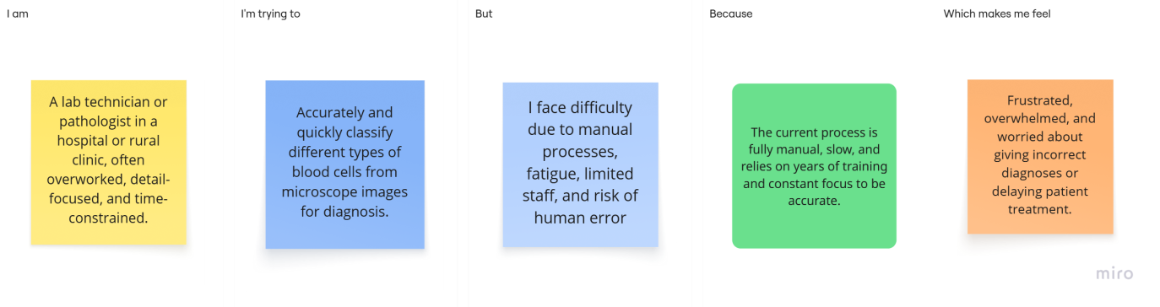

|  |  |  |  |  |  |
| --- | --- | --- | --- | --- | --- |
| **Problem**  **Statement (PS)** | **I am**  **(Customer)** | **I’m trying to** | **But** | **Because** | **Which makes me feel** |
| PS-1 | a lab technician or pathologist | classify blood  cells quickly and accurately | it’s time-  consumin g and errorprone | the process is manual and requires constant focus | Frustrated, overwhelmed, and worried about giving incorrect diagnoses or delaying patient treatment. |